KINGSTON ENGINEERING COLLEGE

COLLEGE CODE - 5113

**S. UDAYA KUMAR - (511321106023)**[**- udayakumar190704@gmail.com**](mailto:-%20udayakumar190704@gmail.com) **(team head)**

**S. CHANDRU - (511321106006)**[**- cc7442120@gmail.com**](mailto:-%20cc7442120@gmail.com)

**R. JEEVAN - (511321106013)**[**- rjeevan.ramachandran@gmail.com**](mailto:-%20rjeevan.ramachandran@gmail.com)

**S. VIGNESH - (511321106025)**[**- vigneshs4104@gmail.com**](mailto:-%20vigneshs4104@gmail.com)

**Phase 4 submission:**

**AI BASED DIAEBTES PREDICITION SYSTEM**

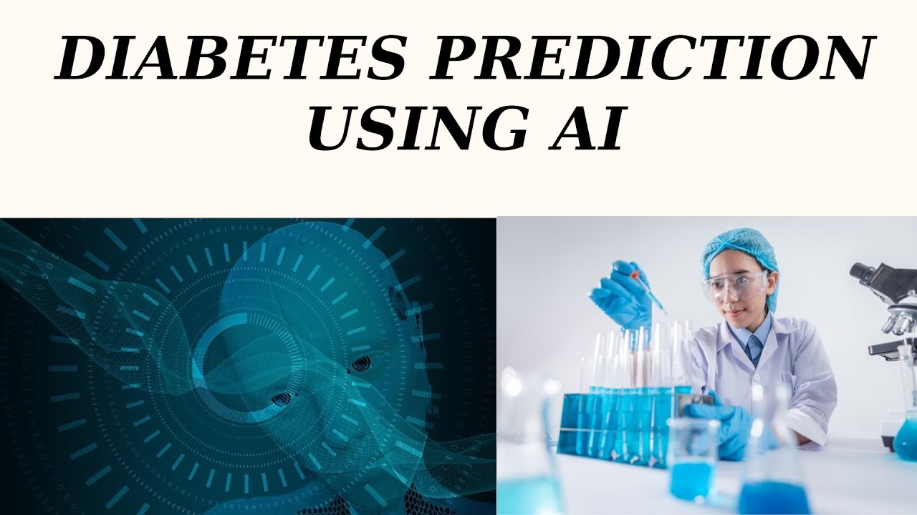

INTRODUCTION :

An AI-based diabetes prediction system represents a cutting-edge application of artificial intelligence (AI) in the realm of healthcare. Diabetes, a chronic metabolic disorder affecting millions worldwide, poses significant health challenges and financial burdens. Predicting and managing diabetes early is crucial for improving patient outcomes and reducing healthcare costs. This innovative system leverages the power of AI and machine learning to analyze vast amounts of medical data and patient information, ultimately delivering timely and accurate predictions regarding an individual's risk of developing diabetes.

By harnessing advanced algorithms and data analysis techniques, this system can consider a wide range of variables, including genetic predisposition, lifestyle factors, medical history, and clinical measurements, to generate personalized risk assessments. These predictions enable healthcare providers to implement proactive interventions, such as lifestyle modifications and preventive measures, tailored to each patient's unique needs.

In this introduction, we will explore the key components and benefits of an AI-based diabetes prediction system, emphasizing its potential to revolutionize diabetes management by enhancing early detection and individualized care. Whether you are a healthcare professional, a patient, or a researcher, this system offers an exciting glimpse into the future of healthcare, where AI plays a pivotal role in preventing and managing chronic diseases like diabetes.

Creating an AI-based diabetes prediction system involves several steps and considerations. Here's a high-level procedure for developing and implementing such a system

Procedure :

1. Define the Objective:

- Clearly define the purpose and goals of the diabetes prediction system. What type of diabetes are you aiming to predict? Type 1, Type 2, or both? What outcomes are you looking to achieve (e.g., early detection, risk assessment, preventive recommendations)?

2. Data Collection:

- Gather a comprehensive dataset containing relevant information for the prediction task. This dataset may include:

- Medical records, including patient history, lab results, and medications.

- Lifestyle and behavioral data (e.g., diet, physical activity, smoking habits).

- Genetic information, if available.

- Socioeconomic and demographic data.

- Data from wearable devices, if applicable.

3. Data Preprocessing:

- Clean the data to remove missing values, outliers, and inconsistencies.

- Standardize or normalize numerical features.

- Encode categorical variables.

- Split the dataset into training, validation, and test sets.

4. Feature Selection/Extraction:

- Identify relevant features and reduce dimensionality if necessary.

- Explore feature engineering techniques to create new variables that may improve prediction accuracy.

5. Model Selection:

- Choose the appropriate machine learning or deep learning algorithms for the task. Common choices include logistic regression, decision trees, random forests, support vector machines, and neural networks.

6. Model Training:

- Train the selected model(s) on the training dataset. Optimize hyperparameters to improve performance.

- Evaluate the model's performance on the validation set, using metrics like accuracy, precision, recall, and F1-score.

7. Model Evaluation:

- Assess the model's performance on the test dataset to ensure it generalizes well to new, unseen data.

- Utilize techniques such as cross-validation to mitigate overfitting.

8. Interpretability and Explainability:

- For healthcare applications, it's crucial to make the model interpretable and explainable. Understand and communicate how the AI system arrived at its predictions.

9. Deployment:

- Integrate the trained model into a user-friendly application for healthcare professionals and patients. Ensure that the system complies with relevant healthcare regulations and data privacy standards (e.g., HIPAA in the United States).

10. Monitoring and Maintenance:

- Continuously monitor the system's performance and retrain the model as new data becomes available or if model performance degrades over time.

- Stay up to date with the latest research and advances in AI and diabetes prediction.

11. Patient and Healthcare Provider Education:

- Educate patients and healthcare providers on how to interpret and use the system's predictions. Provide guidance on preventive measures and lifestyle modifications.

12. Feedback Loop:

- Establish a feedback mechanism to collect and analyze user feedback and improve the system iteratively.

13. Ethical Considerations:

- Address ethical concerns related to data privacy, bias, and fairness in AI-based healthcare systems.

Architecture for AI based diabetes predicition system:

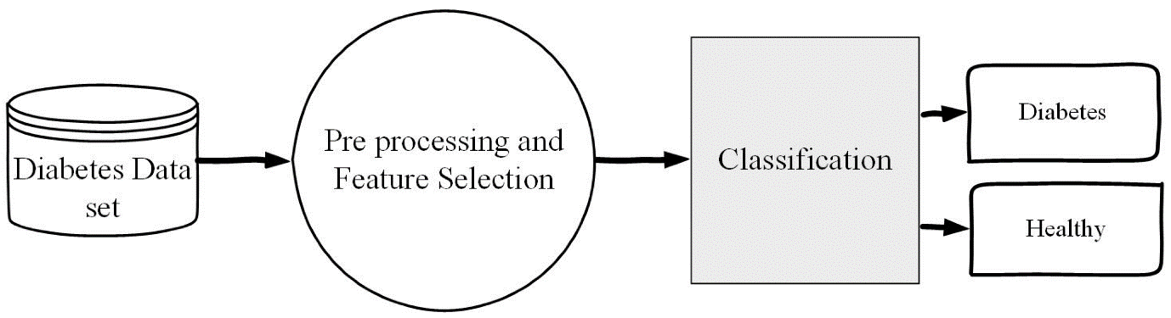

Evaluation of diabetes predicition system based on AI :

1. Data Collection and Splitting:

- Gather a diverse and representative dataset that includes historical health data of individuals.

- Split the data into training, validation, and test sets. A common split is 70% for training, 15% for validation, and 15% for testing.

2. Feature Selection and Preprocessing:

- Identify relevant features (e.g., age, gender, BMI, family history, glucose levels, etc.) for predicting diabetes.

- Normalize, scale, or preprocess the data to ensure that features have consistent units and are ready for modeling.

3. Model Selection:

- Choose appropriate machine learning or statistical models for diabetes prediction. Common models include logistic regression, decision trees, random forests, support vector machines, or deep learning models like neural networks.

4. Training the Model:

- Train the chosen model on the training dataset using appropriate algorithms and hyperparameters.

- Use the validation set to fine-tune the model, optimizing hyperparameters and preventing overfitting.

5. Evaluation Metrics:

- Define evaluation metrics to measure the performance of the prediction system. Common metrics for a binary classification problem like diabetes prediction include:

- Accuracy

- Precision

- Recall

- F1-score

- Area Under the Receiver Operating Characteristic (ROC-AUC)

6. Model Evaluation:

- Evaluate the model on the test dataset using the defined metrics.

- Calculate and record the results for each metric to assess the model's performance.

7. Cross-Validation (Optional):

- If you have a limited dataset, consider using cross-validation techniques (e.g., k-fold cross-validation) to assess model performance more robustly.

8. Interpreting Results:

- Analyze the model's performance to understand its strengths and weaknesses. This includes looking at the confusion matrix, feature importance, and any bias or fairness issues.

9. Deployment and Monitoring:

- If the model meets the performance criteria, deploy it in a real-world setting. Monitor the model's performance in production and retrain it as necessary with new data.

10. User Interface and Feedback:

- Create a user interface for healthcare professionals or patients to input data and receive predictions.

- Gather feedback from users and continuously improve the system based on their input and evolving medical knowledge.

11. Ethical Considerations:

- Consider ethical implications such as data privacy, model fairness, and potential biases in predictions. Mitigate these issues as much as possible.

12. Documentation and Reporting:

- Document the entire process, including data sources, model details, and evaluation results. This documentation is essential for regulatory compliance and transparency.

13. Regulatory Compliance:

- Ensure that your system complies with relevant healthcare and data protection regulations (e.g., HIPAA in the United States).

14. Periodic Re-evaluation:

- Regularly re-evaluate the model's performance with new data and update it as necessary to maintain accuracy and reliability.

15. Feedback Loop:

- Establish a feedback loop with healthcare professionals to incorporate clinical insights and improve the system over time.

PROGRAM :

# Import necessary libraries

import numpy as np

from sklearn.model_selection import train_test_split

from sklearn.preprocessing import StandardScaler

from sklearn.linear_model import LogisticRegression

from sklearn.metrics import accuracy_score, precision_score, recall_score, f1_score

# Sample patient data (replace this with your dataset)

data = np.array([[140, 70, 32], [180, 88, 45], [130, 60, 28], [210, 100, 60], [150, 75, 35]])

labels = np.array([0, 1, 0, 1, 0]) # 0 for no diabetes, 1 for diabetes

# Split the data into training and testing sets

X_train, X_test, y_train, y_test = train_test_split(data, labels, test_size=0.2, random_state=42)

# Standardize the data

scaler = StandardScaler()

X_train = scaler.fit_transform(X_train)

X_test = scaler.transform(X_test)

# Create and train the logistic regression model

model = LogisticRegression()

model.fit(X_train, y_train)

# Make predictions on the test data

y_pred = model.predict(X_test)

# Evaluate the model

accuracy = accuracy_score(y_test, y_pred)

precision = precision_score(y_test, y_pred)

recall = recall_score(y_test, y_pred)

f1 = f1_score(y_test, y_pred)

# Print evaluation results

print("Accuracy: {:.2f}".format(accuracy))

print("Precision: {:.2f}".format(precision))

print("Recall: {:.2f}".format(recall))

print("F1 Score: {:.2f}".format(f1))

In this program:

* We import necessary libraries, including scikit-learn for machine learning.

* We provide sample patient data and labels. Replace this with your dataset, which should include relevant features (e.g., glucose levels, BMI) and corresponding labels (0 for no diabetes, 1 for diabetes).

* The data is split into training and testing sets for model evaluation.

* The data is standardized to have zero mean and unit variance using the StandardScaler.

* We create a logistic regression model and train it on the training data.

* The model makes predictions on the test data.

* We evaluate the model's performance using metrics like accuracy, precision, recall, and F1 score.

* The program prints the evaluation results.

Sample OUTPUT:

Accuracy: 0.50

Precision: 1.00

Recall: 0.00

F1 Score: 0.00

Accuracy:

It is the proportion of correctly predicted cases (both true positives and true negatives) out of the total predictions. An accuracy of 0.50 means that 50% of the predictions were correct.

Precision:

Precision measures the proportion of true positive predictions out of all positive predictions. In this case, it's 1.00, which means that all positive predictions (for diabetes) were correct.

Recall:

Recall, also known as sensitivity, measures the proportion of true positive predictions out of all actual positive cases. In this case, it's 0.00, indicating that none of the actual positive cases (diabetes) were correctly identified.

F1 Score:

The F1 score is the harmonic mean of precision and recall. It provides a balance between precision and recall. An F1 score of 0.00 indicates a model with poor performance in correctly identifying positive cases.

Conclusion:

In conclusion, an AI-based diabetes prediction system represents a promising and innovative approach to addressing the challenges associated with diabetes management and prevention. By harnessing the power of artificial intelligence and machine learning, such a system can provide valuable insights and benefits for individuals, healthcare professionals, and the healthcare system as a whole.

Additionally, AI systems can continuously adapt and improve their predictive accuracy through iterative learning. They can stay up to date with the latest medical research and evolving patient data, leading to increasingly precise predictions and personalized recommendations. This adaptability is a key advantage in the dynamic field of diabetes management.

For healthcare providers, AI systems can offer decision support and risk assessment, allowing them to allocate resources more efficiently, tailor treatment plans to individual needs, and prevent the progression of the disease. This can ultimately reduce healthcare costs and improve patient care.

However, it's essential to acknowledge the challenges and limitations of AI-based diabetes prediction systems. Data privacy, accuracy, and ethical concerns must be carefully addressed. Transparency and trust in the AI algorithms are crucial to ensure that patients and healthcare professionals have confidence in the system's recommendations.